DRAFT RESULTS – Undergoing Final Review

Draft Summary Port of Stockton 2018 Emissions Inventory
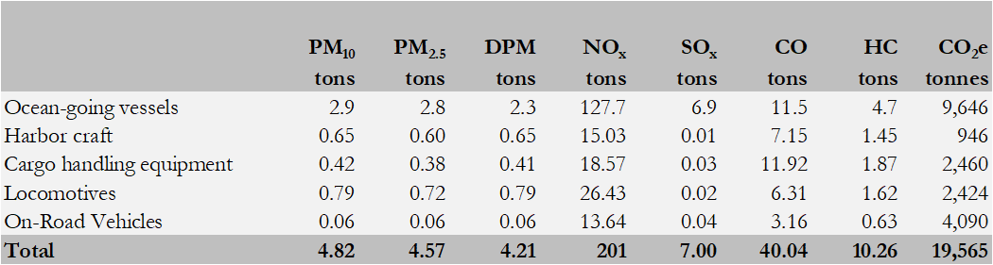

OGV Emissions by Mode
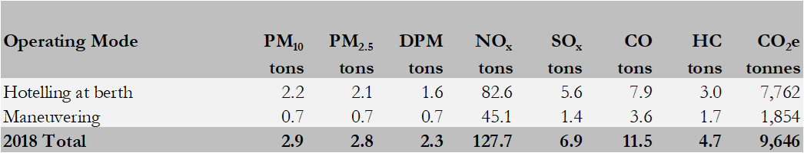
Final results pending review by the Technical Working Group.

1.1 Geographical Domain

The geographical domain for each of the source categories is defined below.

- Ocean going vessels and harbor craft: the over-water geographic domain is within the SJVAPCD boundary which is the San Joaquin river from the confluence of the San Joaquin and Mokelumne rivers to the Port.
- Cargo handling equipment: the geographic domain is within the Port boundary.
- Locomotives: the geographic domain is within the Port boundary and from the Port boundary to the two class one switching yards (approximately 5 miles from the Port).
- On-road vehicles, heavy-duty vehicles: the geographic domain is from the Port to the entrance or exit of the Interstate 5 or State Route 4 freeways.
- On-road vehicles, Port owned on-road vehicles: actual miles traveled which includes mostly on-Port operation.

